**By: Santhosh K**

**Department : CSBS**

**Regno:210421244052**

**Mail:ksanthosh.csbs2021@citchaennai.net**

**VPAT**

**DOCUMENTATION**

**TABLE OF CONTENTS:**

**1. INTRODUCTION**

* Background
* Objectives
* Scope

**2. VULNERABILITY ASSESSMENT AND PENETRATION TEST (VAPT)**

* Definition and Importance
* Methodology

Reconnaissance

Vulnerability Scanning

Exploitation

Post-Exploitation

**3. SECURITY INFORMATION AND EVENT MANAGEMENT (SIEM)**

* Introduction to SIEM
* Need for SIEM
* Implementation
* Monitoring and Alerting

**4. INDEPENDENT CHALLENGES**

1. Download the Academy VM

2. Unzip the 7z file using winrar/winzip/7z to get the VMDisk files

3. Open the VMware Player, select Open VM, and then select the extracted VM

4. Edit the VM and change the network settings to bridged before switching on the VM

5. Use the username and password in the root password.txt file to log in

6. Search the web, and find the solution to turn on the network device ens33 (Hint: unix.stackexchange.com)

7. Once you get connected to the internet, configure your own SIEM Cloud instance in this machine so that any malicious activity can be monitored and tracked

8. Once the SIEM instance is configured, make sure you enable the log files and add the respective directory to the monitor list.

9. Make a note of the IP Address of the VM, exit to the root login page by simply typing 'exit' on a terminal

10. Now, go to your Attacker machine, break into the system, and find the root flag

**1. INTRODUCTION**

**BACKGROUND:**

In today's digital landscape, ensuring the security of web servers is paramount to safeguarding sensitive data and maintaining the trust of users. Moreover, with the evolving threat landscape, enterprises are increasingly turning to Security Information and Event Management (SIEM) solutions to proactively monitor and mitigate security incidents.

**OBJECTIVES:**

This project aims to conduct a comprehensive Vulnerability Assessment and Penetration Testing (VAPT) of the organization's web server to identify and remediate potential security weaknesses. Additionally, it involves the implementation of a SIEM solution to enhance real-time threat detection and incident response capabilities.

**SCOPE:**

The scope of this project encompasses the following:

- Conducting VAPT on the web server infrastructure.

- Implementing a SIEM solution tailored to the organization's needs.

- Providing recommendations for improving the security posture based on findings from VAPT and SIEM implementation.

**2. VULNERBILITY ASSESSMENT AND PENETRATION TESTING (VAPT)**

**DEFINITON AND IMPORTANCE:**

Vulnerability Assessment involves the systematic identification, classification, and prioritization of vulnerabilities within a system, while Penetration Testing simulates real-world attacks to exploit identified vulnerabilities, thereby assessing the effectiveness of existing security measures.

**METHODOLOGY:**

The VAPT process involves several key stages, including reconnaissance, vulnerability scanning, exploitation, and post-exploitation analysis. Each stage is crucial for identifying and validating potential security weaknesses.

**3. SECURITY INFORMATION AND EVENT MANAGEMENT (SIEM)**

**INTRODUCTION TO SIEM:**

An introduction to SIEM technology, its core functionalities, and its role in modern cybersecurity operations.

**NEED FOR SIEM:**

Discussion on the increasing need for SIEM solutions in enterprises to effectively manage security incidents, comply with regulations, and mitigate advanced threats.

**IMPLEMENTATION PROCESS:**

Step-by-step process of implementing the SIEM solution, including requirements gathering, deployment, configuration, and integration with existing systems.

**MONITORING AND ALERTING CAPABILITIES:**

Explanation of the SIEM's monitoring capabilities, including real-time event correlation, anomaly detection, and customizable alerting mechanisms.

**DOCUMENTATION**

Documentation for VAPT (Vulnerability Assessment and Penetration Testing) of a web server and SIEM (Security Information and Event Management) application typically involves detailing the processes, tools, methodologies, and findings related to assessing and testing the security posture of these systems.

**CONFIGURING ACADEMY:**

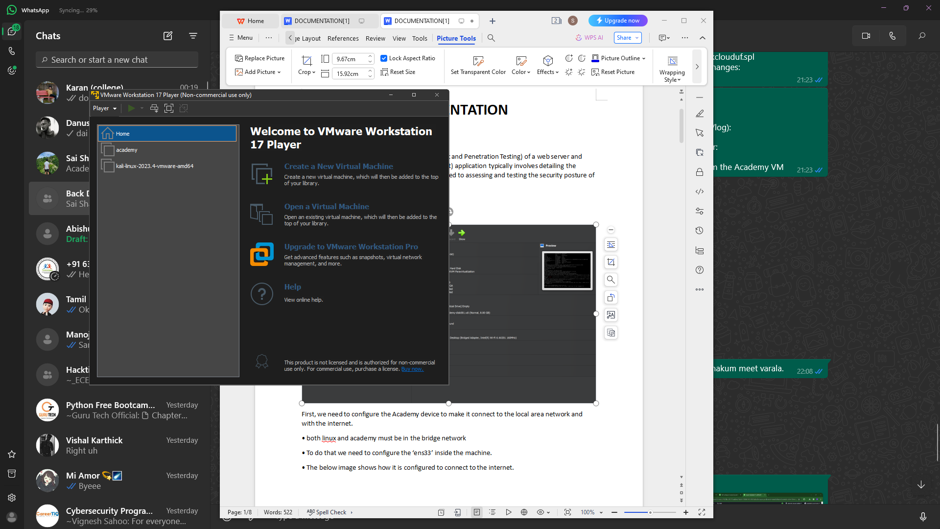

First, we need to configure the Academy device to make it connect to the local area network and with the internet.

• Changing the Linux and Academy networks to bridge

• To do that we need to configure the ‘ens33’ inside the machine.

• The below image shows how it is configured to connect to the internet.

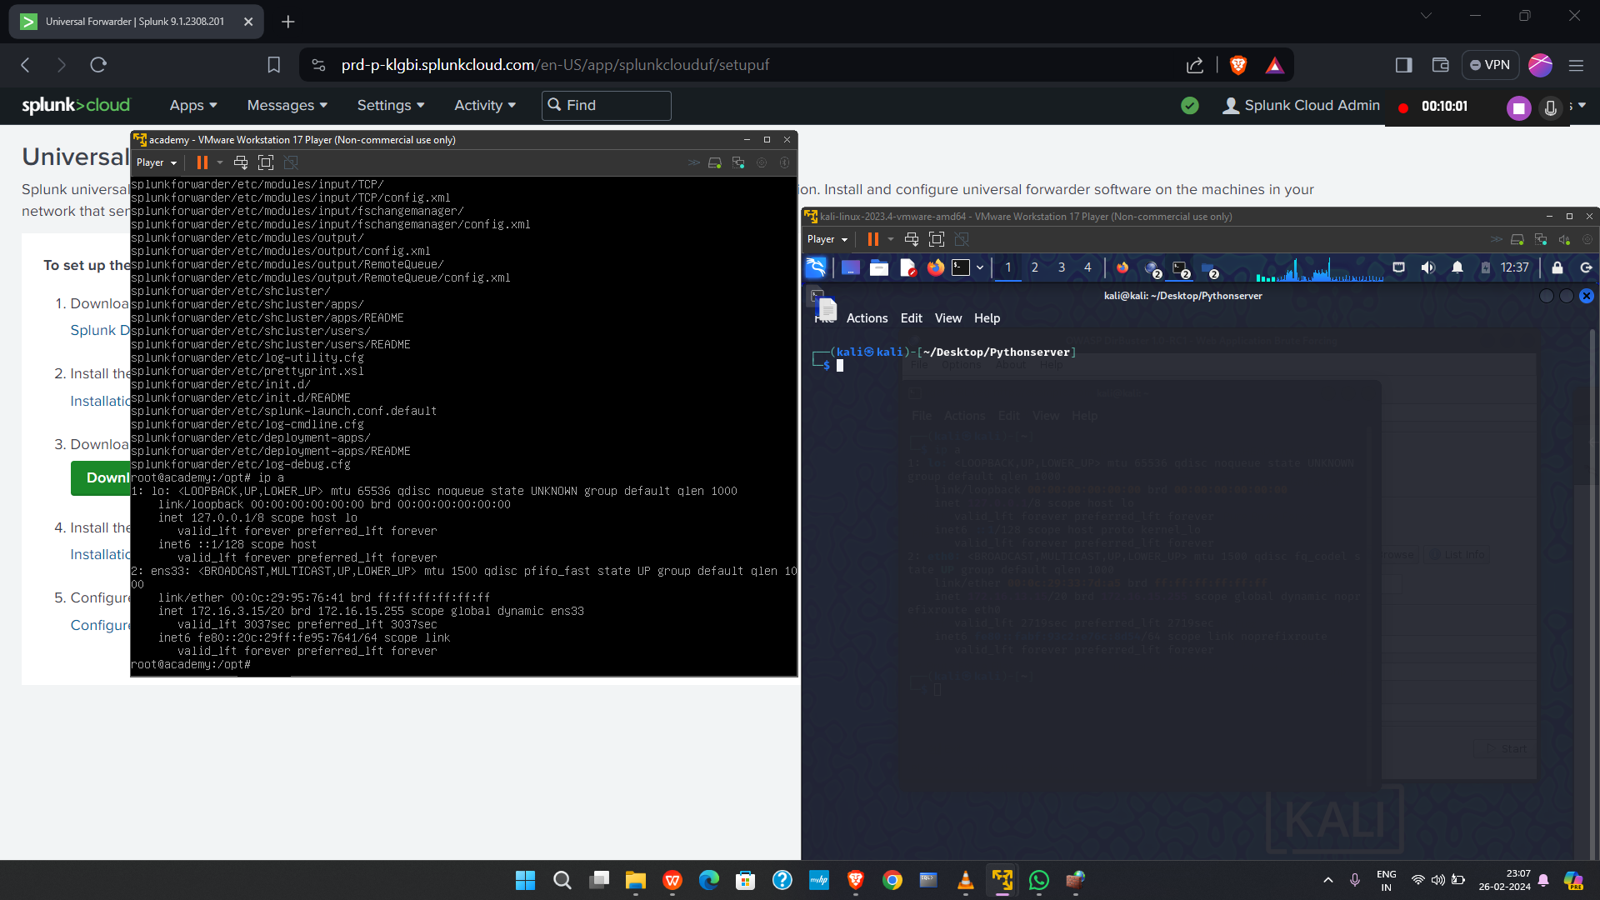

**GETTING IP OF ACADEMY:**

• It initiates the IP assignment from local ‘DHCP’ server using ‘ARP’ protocol.

• After that we get the private IP ADDRESS for our machine. (eg:172.16.3.15)

• Next, we need to install the ‘SPLUNK UNIVERSAL FORWARDER’ in our machine.

• It is done by using the ‘wget’ tool which is available in the Academy machine.

• The below image shows how it is done using the tool.

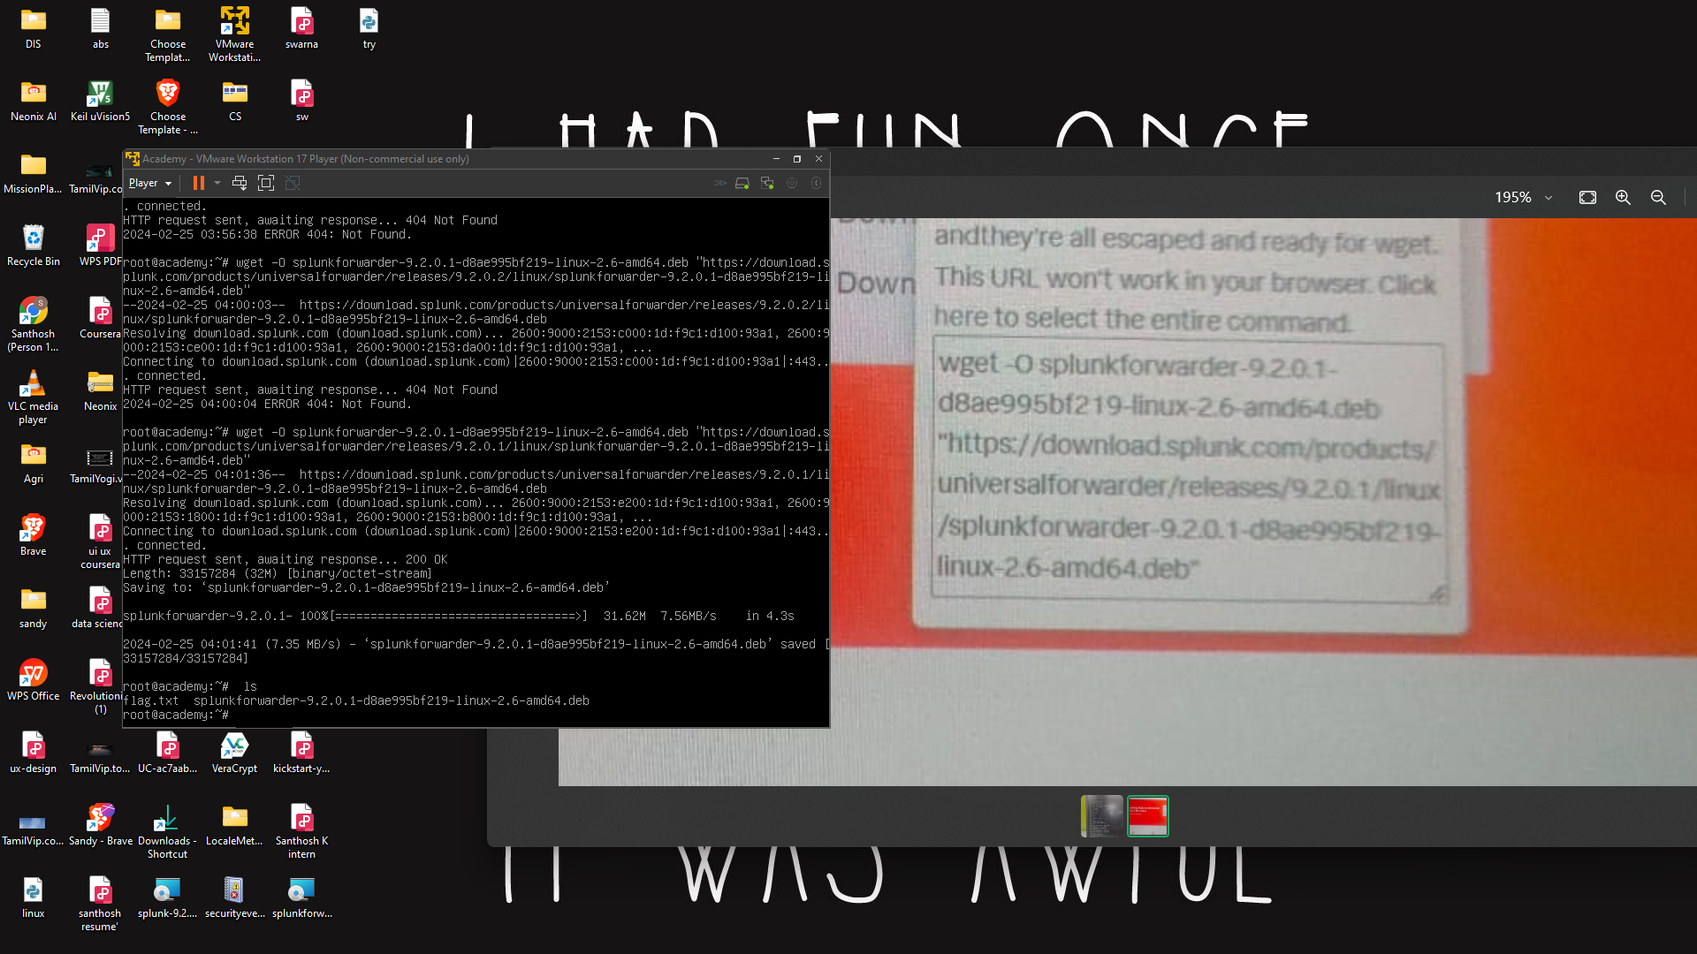

**Installing and Configuring Splunk Universal Forwarder:**

- Create a user for Splunk Forwarder:

useradd -m splunkfwd

nmap 172.16.14.28 -p- -v --min-rate=3000 | tee open_ports.txt

groupadd splunkfwd

- Set up the Splunk Home directory:

export SPLUNK_HOME="/opt/splunkforwarder"

mkdir $SPLUNK_HOME

- Install Splunk Forwarder and start it:

dpkg -i splunkforwarder-9.2.0.1-d8ae995bf219-linux-2.6-amd64.deb

$SPLUNK_HOME/bin/splunk start --accept-license

- Create an admin account for Splunk Forwarder.

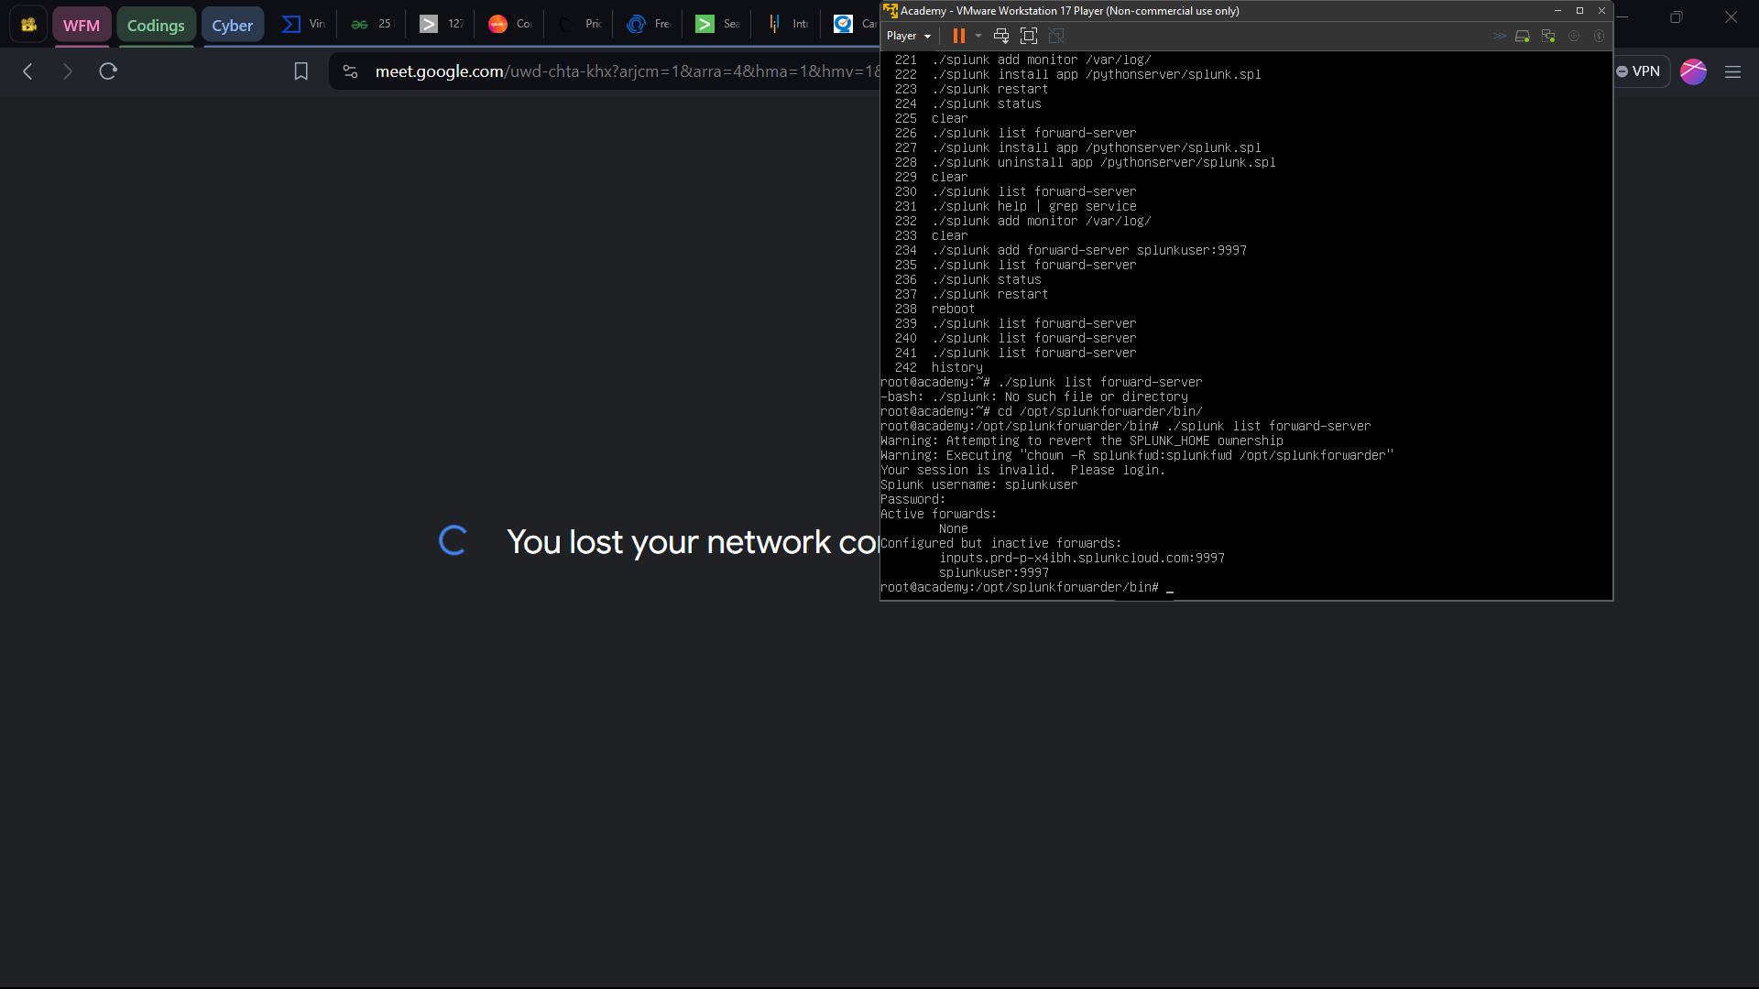

**CONNECTING SPLUNK FORWARDER TO Linux:**

* nmap 172.16.14.28 -p21,22,80 -A -v --min-rate=3000 | tee open_services.txt
* mkdir academy
* $mv open_* academy
* cd academy
* ftp 172.16.14.28

+

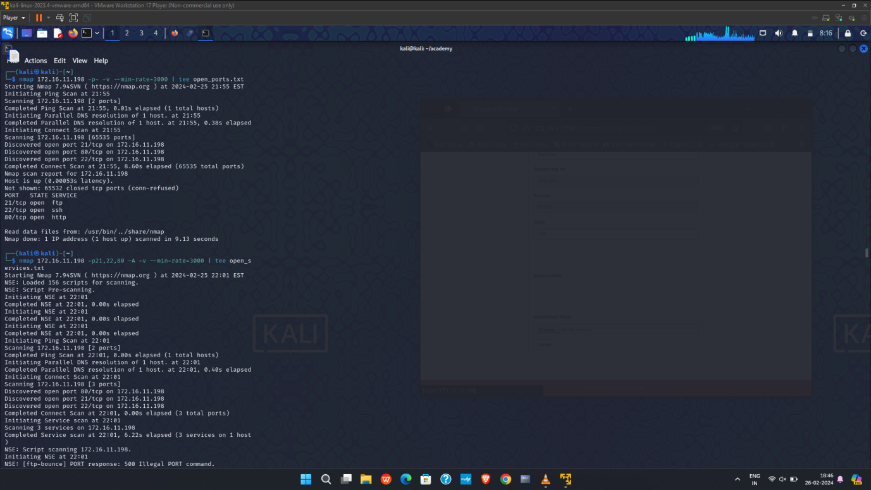

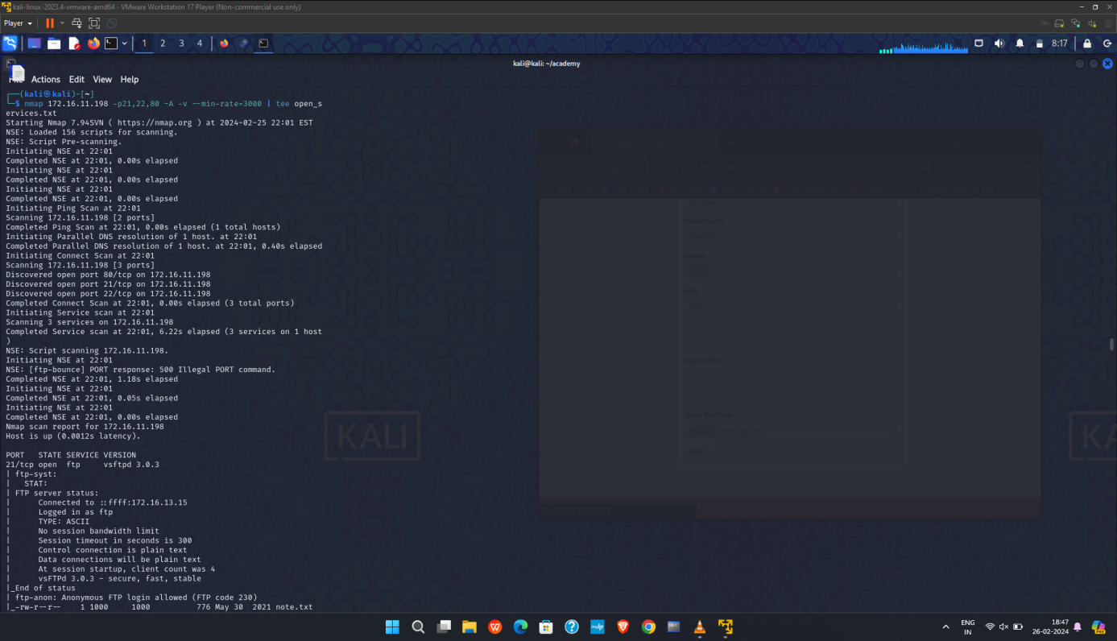

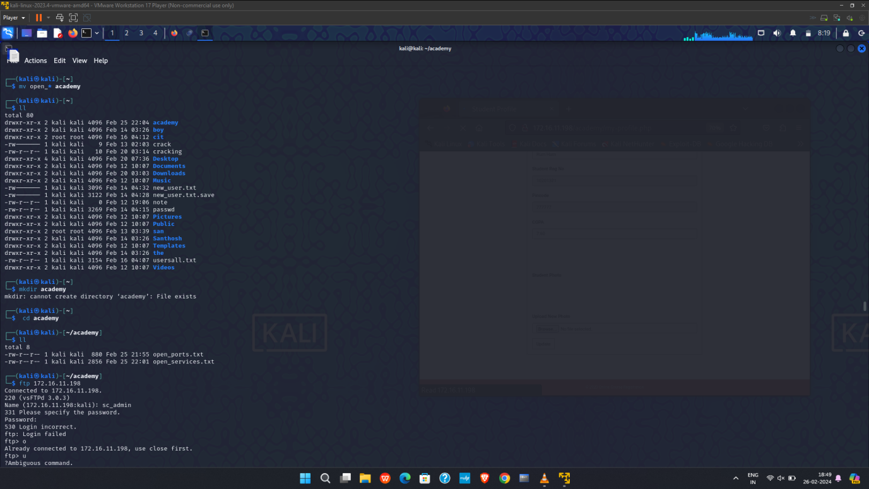

This step involves creating a directory and moving the open_*academy and also installing ftp if that doesn’t exist.

This enables ftp and includes setup and configuration and connecting the ip of academy to ftp.

The ip of academy can be seen by using the command ip a.

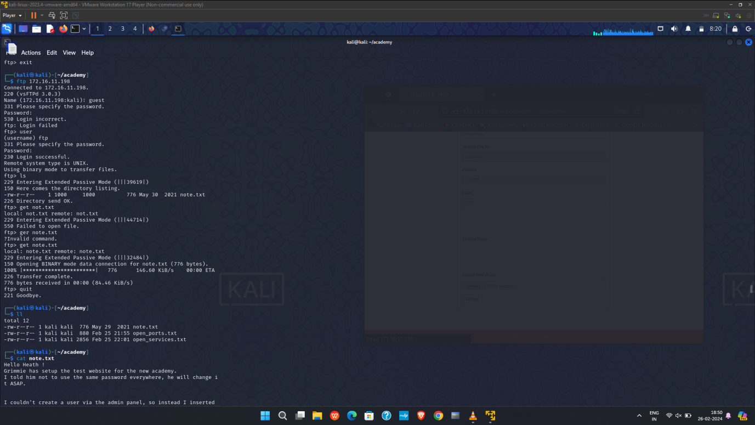

The next step involves creating an user login in ftp .

This requires to specify the password and then the login will be successful.

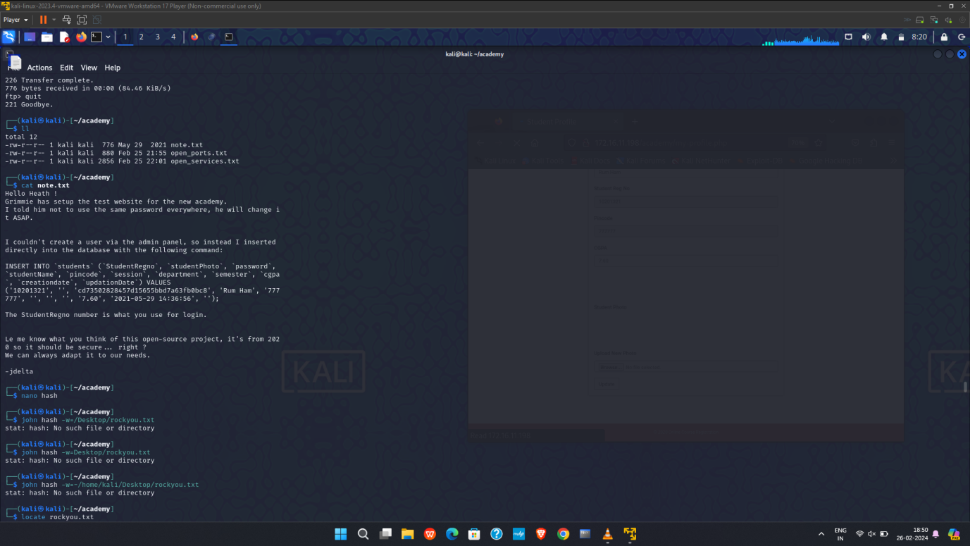

In this we store the value in the text file named note.txt and open a text editor.

We will have hash value and login credentials in that file.

Use the cat command to display the values of login and hash values

I used the MD5 hash decrypter to convert the hash into readable format and thus the decrypted value is “ student “.

Thus we got the password as student and login id as 10201321.

We use this password for login.

For identifying the password we need to find the hash value from the datas stored in the note.txt

After identifying the hash value we need to crack the password to get login access into the login page of academy

Now we need to open the dirbuster application in the Linux os.

And enter the ip of the Linux machine in the dirbuster and maximise the speed and click start.

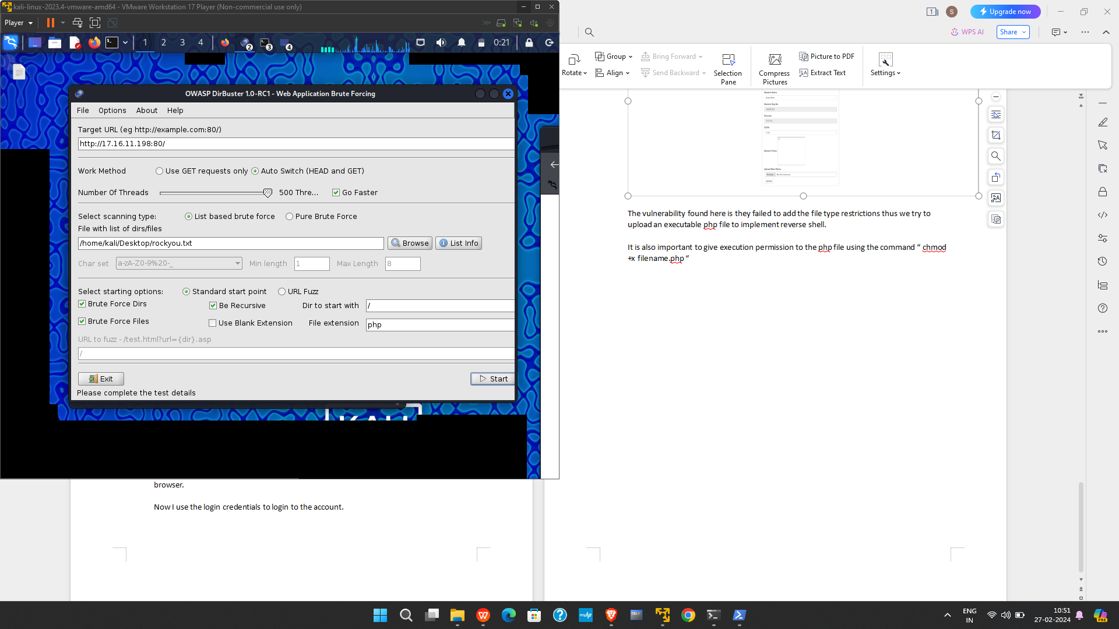

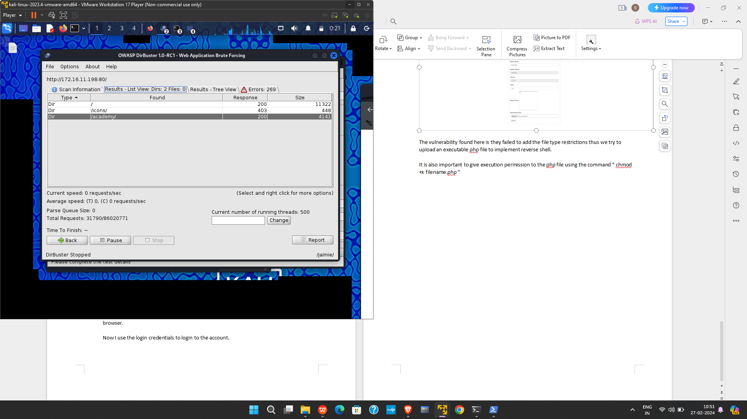

Now find the academy file and right click on the file.

Once done it will show an option called open in browser, this will open the webpage in browser.

Now I use the login credentials to login to the account.

On the login page enter the credentials from the note.txt and the using the cracked password

After this we will be able to acces the my profile page , where we can upload the data into the profile

This is the vulnerability port that is available in this academy login page

After uploading the php file into this port we we be able to get listening access from the login page

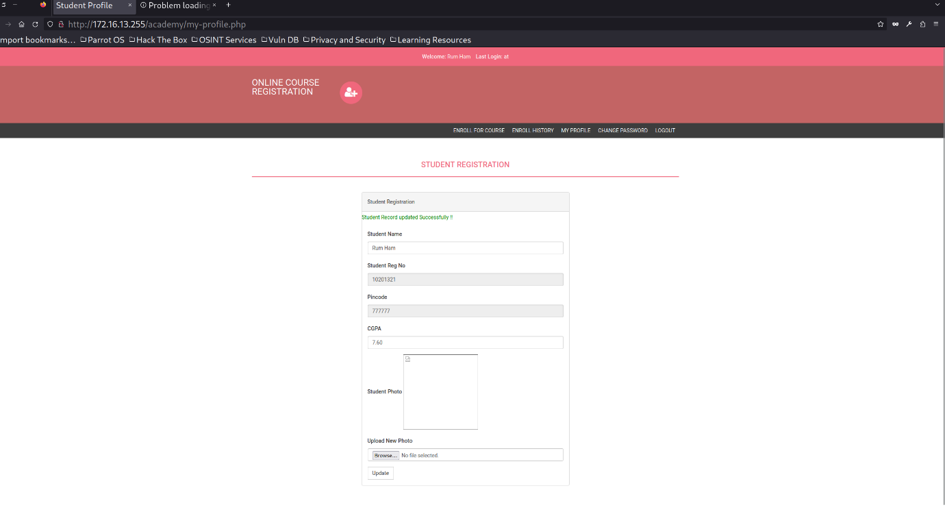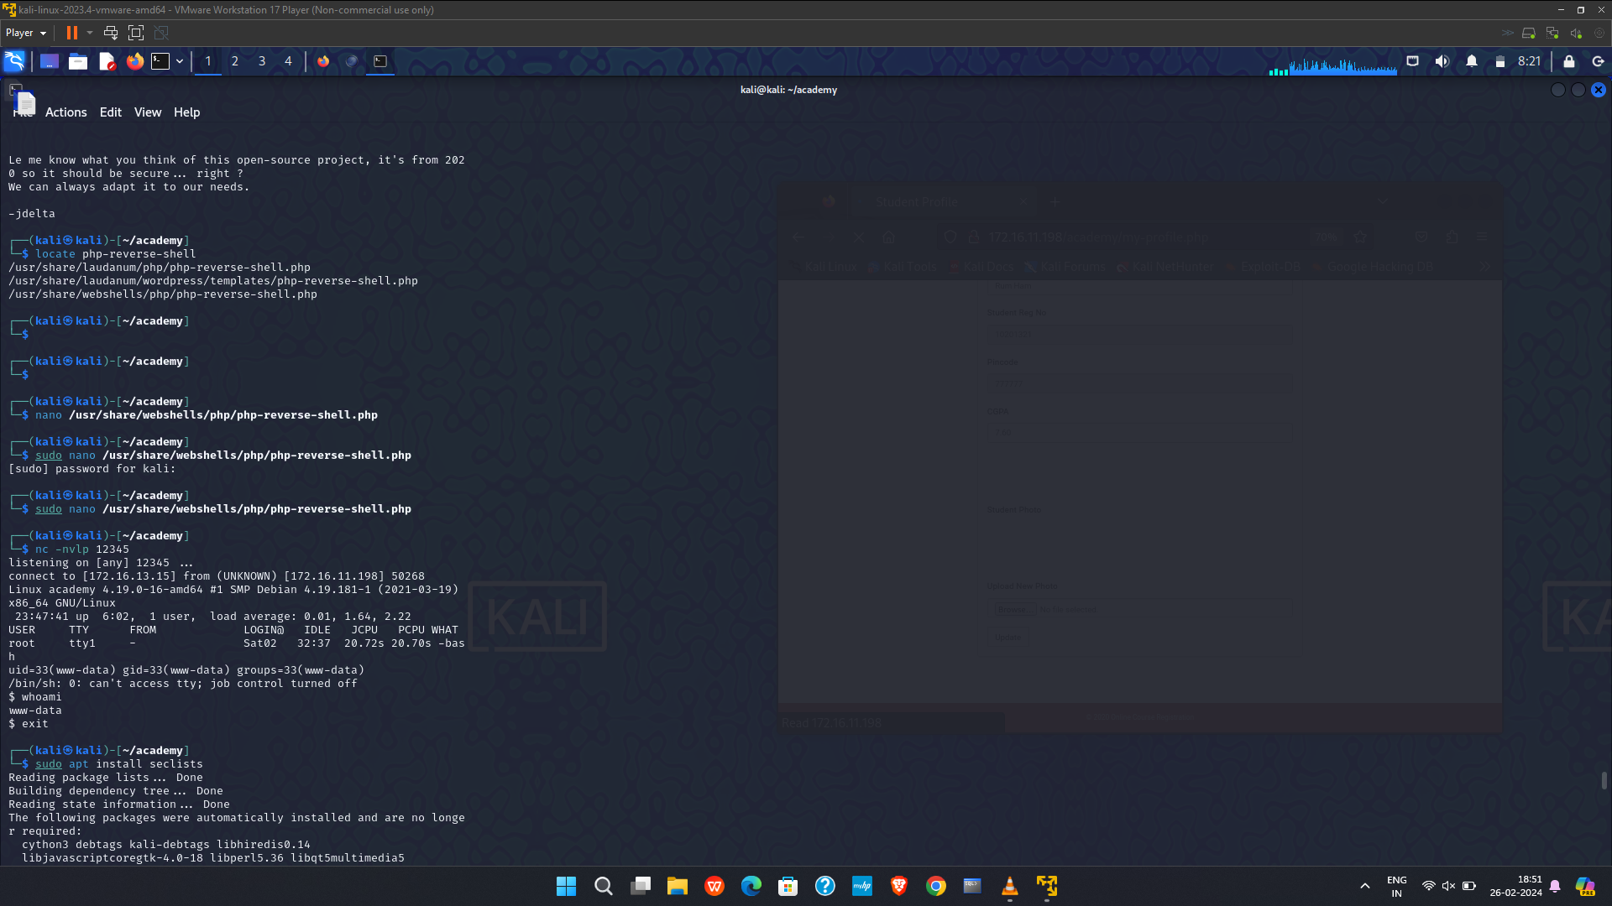

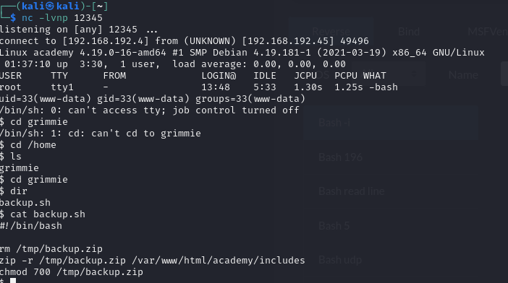

cd /home

ls

grimmie

cd grimmie

cat backup.sh

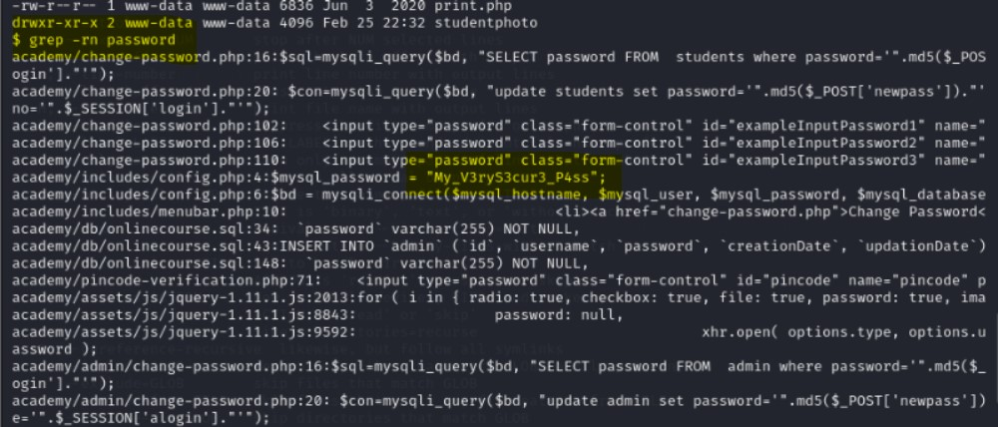

After gathering the password of grimmie we need to connect through ssh

By providing academy’s ip adress and password that we obtained

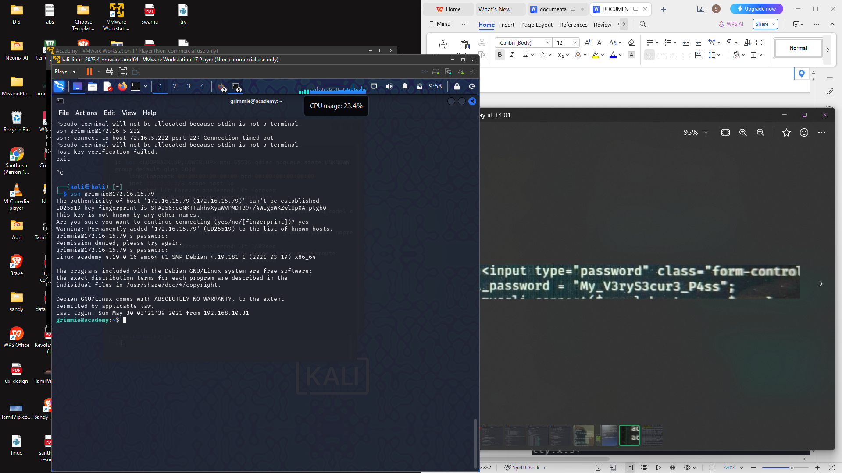

After this we need to insert a listening bash command into the bash file

First we need revshell.com

Providing the ip adress of our kali and port number into it.

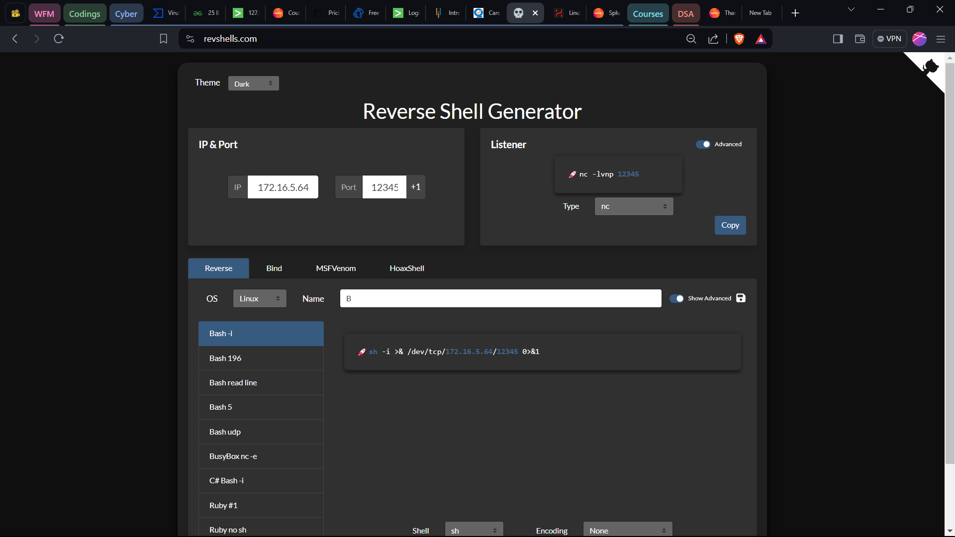

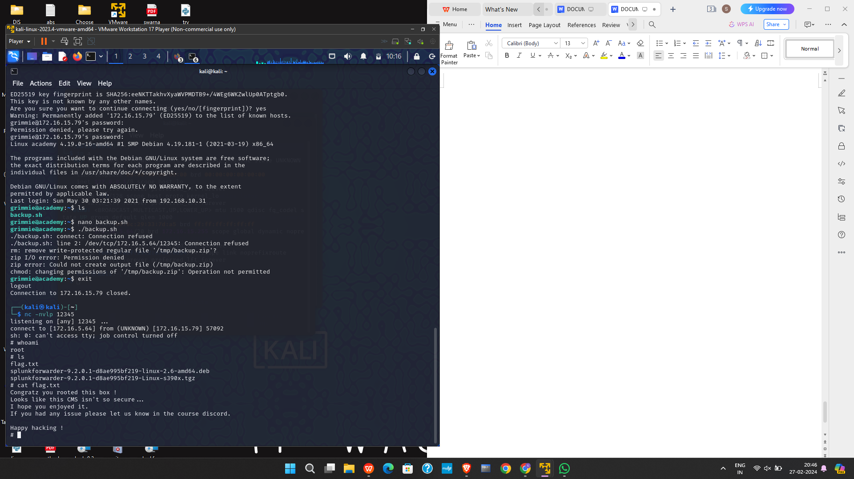

After inserting the bash command into the bash file we will be able to obtain the final result.

We can also check the cloud instances and source

